book

Universidade de Brasília - UnB
Departamento de Engenharia Eletrica - ENE

Pré-relatório Experimento 5
Somadores de palavras binárias e simulação de circuitos em VHDL

Carlos Eduardo Taborda Lottermann
180041509

Prof. Luís Fernando Ramos Molinaro

Brasília, DF
2019
Diagrama de blocos visto 1:
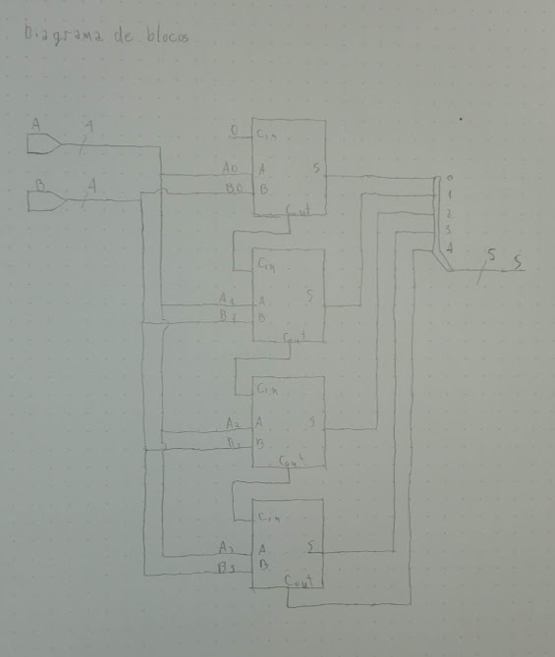
VHDL visto 1
entity Visto_1 is
Port ( A : in STD_LOGIC_VECTOR (3 downto 0);
B : in STD_LOGIC_VECTOR (3 downto 0);
S : out STD_LOGIC_VECTOR (4 downto 0));
end Visto_1;

architecture Visto_1_op of Visto_1 is

component Sum is
Port ( A : in STD_LOGIC;
B : in STD_LOGIC;
Cin : in STD_LOGIC;
S : out STD_LOGIC;
Cout : out STD_LOGIC);
end component;

signal carry : STD_LOGIC_VECTOR (3 downto 0);

begin

S0: Sum port map(A(0),B(0),'0',S(0),carry(0));
S1: Sum port map(A(1),B(1),carry(0),S(1),carry(1));
S2: Sum port map(A(2),B(2),carry(1),S(2),carry(2));
S3: Sum port map(A(3),B(3),carry(2),S(3),carry(3));
S(4) <= carry(3);

end Visto_1_op;

VHDL visto 2:
entity Visto_2 is
Port ( A : in UNSIGNED (3 downto 0);
B : in UNSIGNED (3 downto 0);
S : out STD_LOGIC_VECTOR (4 downto 0));
end Visto_2;

architecture Visto_2_op of Visto_2 is

begin

S <= ('0' & A) + ('0' & B);

end Visto_2_op;

VHDL visto 3:
entity testbench is
Port ( F_dut : in STD_LOGIC_VECTOR (4 downto 0);
F_gm : in STD_LOGIC_VECTOR (4 downto 0);
A : out STD_LOGIC_VECTOR (3 downto 0);
B : out STD_LOGIC_VECTOR (3 downto 0));
end testbench;
architecture test of testbench is
begin
process
variable cont : STD_LOGIC_VECTOR (7 downto 0);
begin

cont := "00000000";

for i in 1 to 256 loop

A(0) <= cont(0);
A(1) <= cont(1);
A(2) <= cont(2);
A(3) <= cont(3);
B(0) <= cont(4);
B(1) <= cont(5);
B(2) <= cont(6);
B(3) <= cont(7);
wait for 500 ns;

assert (F_dut = F_gm);

cont := cont + 1;

end loop;

wait;
end process;
end test;
Testbench:
ENTITY test IS
END test;

ARCHITECTURE behavior OF test IS

COMPONENT testbench
PORT(
F_dut : IN std_logic_vector(4 downto 0);
F_gm : IN std_logic_vector(4 downto 0);
A : OUT std_logic_vector(3 downto 0);
B : OUT std_logic_vector(3 downto 0)
);
END COMPONENT;

COMPONENT Visto_1
PORT(
A : in STD_LOGIC_VECTOR (3 downto 0);
B : in STD_LOGIC_VECTOR (3 downto 0);
S : out STD_LOGIC_VECTOR (4 downto 0)
) ;
END COMPONENT;

COMPONENT Visto_2
PORT(
A : in UNSIGNED (3 downto 0);
B : in UNSIGNED (3 downto 0);
S : out STD_LOGIC_VECTOR (4 downto 0)
) ;
END COMPONENT;

signal F_dut : std_logic_vector(4 downto 0);
signal F_gm : std_logic_vector(4 downto 0);

signal A : std_logic_vector(3 downto 0);
signal B : std_logic_vector(3 downto 0);
BEGIN

U0: Visto_1 port map(A, B, F_dut);
U1: Visto_2 port map(A, B, F_gm);
U2: testbench port map(F_dut, F_gm, A, B);

END;

Arquivo UCF:
NET "A(0)" LOC = "P11";
NET "A(1)" LOC = "L3";
NET "A(2)" LOC = "K3";
NET "A(3)" LOC = "B4";
NET "B(0)" LOC = "G3";
NET "B(1)" LOC = "F3";
NET "B(2)" LOC = "E2";
NET "B(3)" LOC = "N3";

NET "S(0)" LOC = "M5";
NET "S(1)" LOC = "M11";
NET "S(2)" LOC = "P7";
NET "S(3)" LOC = "P6";
NET "S(4)" LOC = "N5";

